A PROJECT REPORT

Submitted by-

Ayush Dwivedi (24BCS11411)

in partial fulfillment for the award of the degree of

BACHELOR OF ENGINEERING

IN

COMPUTER SCIENCE & ENGINEERING


Chandigarh University

APRIL, 2026

TABLE OF CONTENTS
List of Figure
CHAPTER 1. INTRODUCTION TO PROJECT…………..………………….3
  - Introduction to Project 3
1.2 Identification of Problem 3
CHAPTER 2. BACKGROUND STUDY 4
  - Existing solutions 4
  - Problem Definition 4
2.3 Goals/Objectives 4-5
CHAPTER 3. DESIGN FLOW 5
  - Evaluation & Selection of Specifications/Features 5
  - Analysis of Features and finalization subject to constraints 5-6
  - Algorithm and Concepts Used …………………………………………………………….6-8
3.4 Design Flow 8
3.5 TECH STACK USED 8-9
3.6 Flow Diagram ………………………………………………………………………….9-10
CHAPTER 4. RESULTS ANALYSIS AND VALIDATION 10
4.1 Implementation of solution 10
4.2 Output Description …………………………………………………………………….11
4.3 Validation and Testing …………………………………………………………………11
4.4 Result and Analysis …………………………………………………………………….11-12
CHAPTER 5. CONCLUSION AND FUTURE WORK 12
  - Conclusion………………………………………………………………………………12
  - Learning Outcomes ……………………………………………………………………...12
  - Limitations ………………………………………………………………………………13
  - Future Work ……………………………………………………………………………..13
  - Summary ………………………………………………………………………………..13
  - References ………………………………………………………………………………13-14

CHAPTER 1 -INTRODUCTION

1.1 Introduction to Project

The QuizEngine – Algorithm-Powered Interactive Quiz Platform is a full-stack web application that efficiently manages quizzes and user performance using modern web technologies and core data structures and algorithms. Each quiz consists of dynamically generated questions associated with specific topics, where user responses are processed and evaluated in real time.

The purpose of this project is to design a scalable and intelligent system capable of conducting quizzes, evaluating performance, managing topics, and displaying leaderboards without relying on static question sets or manual evaluation. By implementing algorithms such as random shuffling, greedy scoring, and graph-based topic dependencies, the system ensures fairness, adaptability, and structured learning progression.

The project uses full-stack development concepts including frontend-backend communication, REST APIs, and database management along with programming principles like modular design and dynamic data handling. All operations are performed through an interactive web interface, making it intuitive for users to navigate, attempt quizzes, and track their progress.

This project not only serves as a practical solution for online learning and assessment platforms but also as an academic demonstration of how data structures and algorithms can be applied to solve real-world problems in system design, performance evaluation, and user management.

1.2 Identification of Problem

Conventional quiz systems often suffer from inefficiencies due to static question sets and lack of adaptive logic. Many existing platforms present the same sequence of questions to all users, which reduces fairness and fails to provide a personalized learning experience. Additionally, manual evaluation or simplistic scoring methods do not accurately reflect user performance.

The major issues observed include:

Lack of randomization leading to predictable question patterns

Inefficient scoring systems that do not reward consistency or streaks

No structured topic progression, allowing users to skip important prerequisites

Poor performance tracking and limited insights into user progress

Scalability issues in handling dynamic user data and real-time updates

Therefore, the identified problem is the absence of an intelligent, dynamic, and scalable quiz system that can efficiently manage quizzes, evaluate performance in real time, and guide users through a structured learning path.

CHAPTER 2 – BACKGROUND STUDY

2.1 Existing Systems

Most existing quiz platforms are web-based applications that rely on predefined question sets and simple scoring mechanisms. Many of these systems use traditional database-driven architectures with static quiz flows, where all users receive the same sequence of questions without personalization or adaptability.

At the academic level, basic quiz applications are often implemented using simple logic or static arrays, lacking advanced features such as real-time scoring, topic-based progression, or performance tracking. These systems may support basic quiz functionality but fail to incorporate efficient algorithms or scalable architectures.

Some modern platforms provide interactive interfaces and leaderboards, but they often lack structured learning paths or fail to utilize data structures like graphs for managing dependencies between topics. As a result, users can attempt advanced topics without mastering prerequisites, reducing learning effectiveness.

2.2 Problem Definition

The goal of this project is to design a full-stack quiz system that dynamically manages quizzes, evaluates performance, and controls topic progression.

The system aims to:

Eliminate static quiz patterns

Provide randomized question order

Implement efficient real-time scoring

Ensure topic-based progression using graph logic

Maintain user performance and history

In short, the problem statement can be summarized as:

“Design and implement an algorithm-based quiz system that provides dynamic quizzes, real-time evaluation, and structured topic progression in an efficient and user-friendly manner.”

2.3 Goals and Objectives

The main objective is to build an efficient and modular quiz system using algorithms and full-stack development.

Specific goals include:

To implement randomized quiz generation

To design a greedy scoring system

To use graph-based topic unlocking

To develop secure authentication

To provide leaderboard and history tracking

To create a user-friendly interface

To demonstrate the use of data structures and algorithms

CHAPTER 3 – DESIGN FLOW / PROCESS

3.1 Evaluation and Selection of Specifications / Features

Before finalizing the implementation, several approaches were evaluated—using static quiz systems, simple random functions, and algorithm-based methods. Static systems were easy to implement but lacked flexibility, while basic randomization was often biased and unreliable. Algorithm-based techniques were selected as the optimal approach for this project because they provide fairness, efficiency, and scalability.

Key features chosen for the system:

Start Quiz – Generate randomized questions dynamically

Submit Quiz – Evaluate answers and calculate score

Topic Unlocking – Control access using prerequisite logic

Leaderboard – Display top users based on score

Quiz History – Track previous attempts

Authentication – Secure login and registration

3.2 Analysis of Features and Finalization
Each functionality was analyzed for efficiency and correctness:
- Start Quiz:
  - Uses shuffle algorithm for random questions
  - Ensures no repetition within a session
- Submit Quiz:
  - Applies greedy scoring logic
  - Adds streak-based bonus points
- Topic Unlocking:
  - Uses graph traversal logic
  - Checks completion of prerequisites
- Leaderboard:
  - Sorts users based on score
  - Handles tie-breaking consistently
- Quiz History:
  - Stores past attempts
  - Allows users to track progress
- Authentication:
  - Uses JWT for secure access
  - Protects user-specific routes
This modular design ensures the system is efficient, scalable, and easy to maintain.
3.3 Algorithms & Core Concepts Used
1. Fisher–Yates Shuffle Algorithm
- The Fisher–Yates Shuffle is used to randomly shuffle the order of quiz questions.
- It works by iterating through the list of elements and swapping each element with another randomly selected element.
- This ensures that every possible permutation of the list has an equal probability.
- Why it is used:
- To prevent predictability in quizzes.
- To make each attempt unique and fair.
- Time Complexity: O(n)

2. Greedy Algorithm (Scoring System)
- The scoring system in the quiz engine follows a greedy approach, where decisions are made step-by-step to maximize immediate benefit.
- Points are awarded for correct answers.
- Points may be deducted for incorrect answers.
- Bonus points are given for consecutive correct answers (streaks).
- Why it is used:
- It provides an efficient way to calculate scores dynamically.
- Encourages consistent performance through streak bonuses.
3. Graph Theory and Topological Sorting (Kahn’s Algorithm)
- The quiz topics are structured as a Directed Acyclic Graph (DAG), where:
- Each node represents a topic.
- Edges represent dependencies between topics.
- A topological sort (using Kahn’s Algorithm) is applied to determine the correct order in which topics should be attempted.
- Why it is used:
- Ensures prerequisites are completed before advancing.
- Maintains a logical progression of learning.
4. Sorting Algorithms (Multi-Criteria Sorting)
- Sorting is used in features like:
- Leaderboards
- Question organization
- In leaderboards:
- Users are sorted primarily by score (descending).
- In case of a tie, secondary criteria like name or time may be used.
- Why it is used:
- To rank users efficiently.
- To display data in a meaningful and structured way.

5. JWT (JSON Web Token) Authentication
- JWT is used to handle user authentication securely.
- When a user logs in, a token is generated and sent to the client.
- This token is used to verify the user in subsequent requests.
- Why it is used:
- Ensures secure access to protected routes.
- Avoids repeated login requests.
- Maintains user session without storing data on the server.

3.4 Design Flow

The system’s operation can be summarized through this logical sequence:

Start Application

User Registers / Logs In

Display Dashboard

User Selects Topic

Check Topic Unlock Status

Start Quiz → Load Questions → Answer Questions

Submit Quiz → Evaluate Score → Store Result

Update Leaderboard

View History or Attempt Another Quiz

Logout / Exit System

3.5 TECH STACK USED
The QuizEngine platform is built using a modern full-stack architecture, combining frontend, backend, and database technologies to ensure scalability, performance, and seamless user experience.

1. Frontend Technologies
- React.js
  - Used for building dynamic and responsive user interfaces
  - Enables component-based architecture for better code reusability
- HTML5, CSS3, JavaScript
  - Structure, styling, and interactivity of the web application
- Axios / Fetch API
  - Handles communication with backend APIs

2. Backend Technologies
- Node.js
  - Provides a runtime environment for executing JavaScript on the server
- Express.js
  - Lightweight framework used to build RESTful APIs
  - Handles routing, middleware, and server-side logic

3. Database
- MongoDB
- NoSQL database used to store:
  - User data
  - Quiz questions
  - Scores and history
  - Provides high scalability and flexible schema design

4. Authentication & Security
- JWT (JSON Web Token)
  - Used for secure user authentication
  - Ensures protected API routes and session management

3.6 Flow Diagram (Textual Representation)

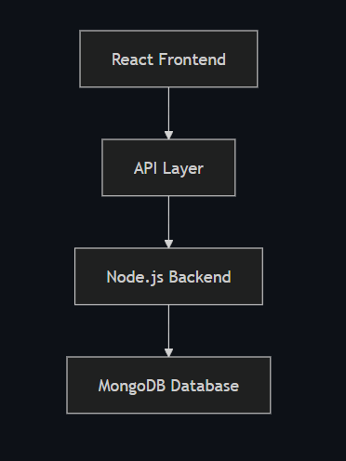

CHAPTER 4 – RESULTS ANALYSIS AND VALIDATION

4.1 Implementation of Solution

The QuizEngine system is implemented using a full-stack approach with React.js, Node.js, Express.js, and MongoDB. The application is divided into frontend and backend modules, which communicate through REST APIs.

The backend handles core functionalities such as user authentication, quiz management, scoring, and topic unlocking. JWT is used to secure user sessions and protect API routes. The database stores users, topics, questions, and quiz attempts efficiently.

The frontend provides an interactive user interface where users can log in, select topics, attempt quizzes, and view results. It communicates with the backend using API calls and updates data in real time.

The system implements dynamic quiz generation, real-time scoring, and structured topic progression. All modules are designed in a modular manner, ensuring scalability, maintainability, and efficient performance of the application.

4.2 Output Description

The QuizEngine system produces clear and interactive outputs at each stage of user interaction. After successful login, the user is presented with a dashboard displaying available topics and their unlock status.

When a quiz is started, questions are displayed one by one with multiple-choice options. As the user answers questions, the system processes responses and updates the score accordingly.

After submitting the quiz, the system displays the final score along with performance details. The results are also stored in the database for future reference.

The leaderboard shows a ranked list of users based on their scores, while the history section displays previous quiz attempts. All outputs are presented in a structured and user-friendly format, ensuring easy understanding and smooth navigation.

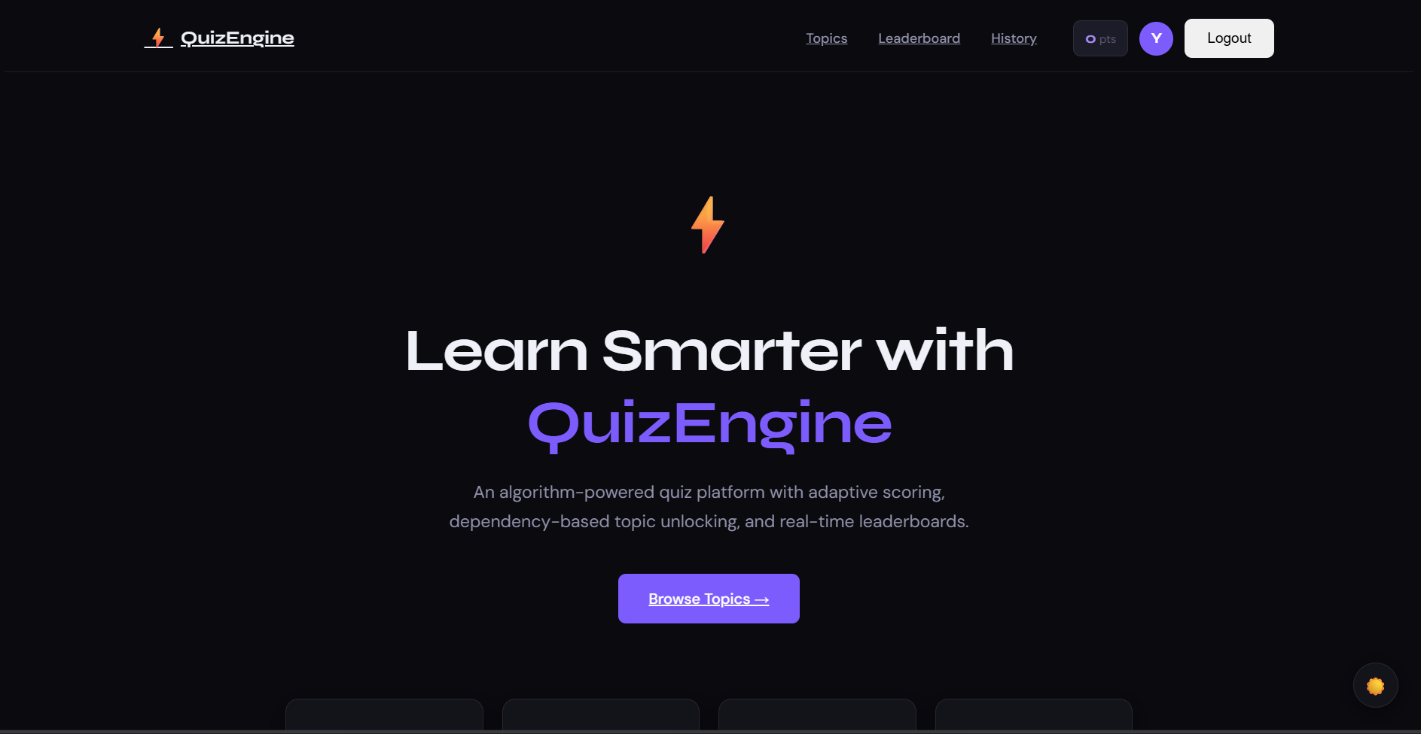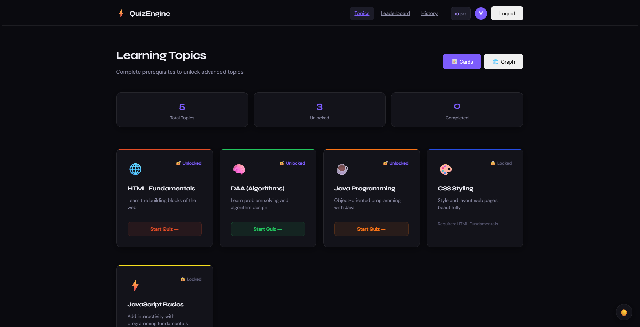

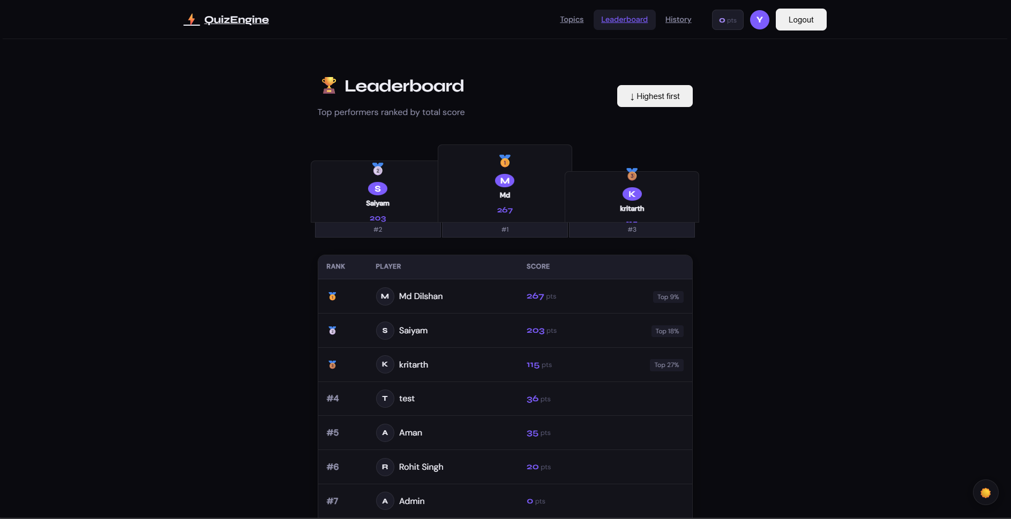

4.3 Validation and Testing

The QuizEngine system was tested to ensure correctness, reliability, and proper functionality of all features. Validation checks were implemented at both frontend and backend levels to prevent invalid data and ensure smooth operation.

Input validation is applied during user registration, login, and quiz attempts to ensure correct data formats and required fields. Duplicate entries and invalid inputs are handled appropriately with error messages.

Functional testing was performed on all modules, including authentication, quiz generation, scoring, topic unlocking, and leaderboard updates. Each feature was tested with different scenarios to verify correct behavior.

The system was also tested for edge cases such as empty inputs, invalid credentials, and unauthorized access. API routes were secured and verified using JWT authentication.

Overall, the testing process confirms that the system works accurately, handles errors effectively, and provides a stable and reliable user experience.

4.4 Performance Analysis

The performance of the QuizEngine system is evaluated based on efficiency, scalability, and response time. The application performs efficiently due to the use of optimized algorithms and a modular full-stack architecture.

The Fisher–Yates shuffle algorithm ensures randomization of questions in linear time, making quiz generation fast even with large datasets. The greedy scoring algorithm evaluates answers instantly, enabling real-time score updates without delay.

The system handles user requests through REST APIs, providing quick responses for operations like login, quiz loading, and result submission. MongoDB enables efficient data storage and retrieval, ensuring smooth performance during multiple user interactions.

Overall, the system demonstrates good performance with minimal delay, efficient resource utilization, and the ability to scale for larger datasets and multiple users.

CHAPTER 5 – CONCLUSION AND FUTURE WORK

5.1 Conclusion

The QuizEngine project successfully demonstrates the implementation of a dynamic and algorithm-based quiz system using modern full-stack technologies. It overcomes the limitations of traditional quiz platforms by introducing features like randomized question generation, real-time scoring, and structured topic progression.

The use of algorithms such as Fisher–Yates shuffle, greedy scoring, and graph-based dependency management ensures fairness, efficiency, and logical learning flow. The system is designed in a modular way, making it scalable and easy to maintain.

Overall, this project highlights how data structures, algorithms, and web development can be combined to build an efficient, user-friendly, and practical application for learning and assessment.

5.2 Learning Outcomes

Through the development of the QuizEngine project, several important concepts and skills were learned:

Understanding of full-stack development using React, Node.js, and MongoDB

Practical application of data structures and algorithms in real-world problems

Implementation of Fisher–Yates shuffle, greedy algorithms, and graph-based logic

Knowledge of REST API development and client-server communication

Experience with JWT-based authentication and security

Improved skills in modular coding and project structuring

Ability to design interactive and user-friendly interfaces

Understanding of database design and data management

5.3 Limitations

Limited number of questions (based on seed data)

No AI-based difficulty adaptation

Requires internet connection to function

Basic leaderboard without advanced analytics

No multiplayer or real-time competition mode

Limited admin controls for content management

5.4 Future Work

The QuizEngine project can be further improved with the following enhancements:

Implementation of AI-based question recommendation

Addition of multiplayer quiz mode for real-time competition

Advanced analytics dashboard for performance insights

Expansion of question database with more topics

Improved admin panel for better content management

Integration of voice-based or interactive quizzes

Development of a mobile application version

5.5 Summary

The QuizEngine project is a full-stack web application designed to provide an interactive and efficient quiz experience. It integrates modern technologies with algorithm-based logic to manage quizzes, evaluate performance, and control topic progression.

The system uses features like randomized question generation, greedy scoring, and graph-based topic unlocking to ensure fairness and structured learning. It also includes user authentication, leaderboard ranking, and quiz history tracking.

Overall, the project demonstrates the practical implementation of data structures, algorithms,full-stack development in building a scalable and user-friendly application for learning and assessment.

5.6 References
- MongoDB Documentation - www.mongodb.com/docs
- React Documentation - react.dev
- Node.js Documentation - nodejs.org/docs
- Express.js Documentation - expressjs.com
- JSON Web Token (JWT) - jwt.io
- MDN Web Docs - developer.mozilla.org
- GeeksforGeeks (Data Structures and Algorithms) - www.geeksforgeeks.org
- Fisher Yates Shuffle Algorithm - en.wikipedia.org/wiki/Fisher-Yates_shuffle
- Topological Sorting Algorithm - en.wikipedia.org/wiki/Topological_sorting

